**Lab Report**

Title: Finding Coffee Shops That Are in the MPCA Sites Around My Home Using APIs (Lab 1)

Notice: Dr. Bryan Runck

Author: Mohsen Ahmadkhani

Date: 11/1/2021

**Project Repository:** <https://github.com/mohsen-gis/GIS5571.git>

**Google Drive Link:** -

**Time Spent:** 35 hours

**Abstract**

This lab consists of two parts. Part 1 mostly includes raster data visualization and manipulation. In this part I developed an ETL process that downloads a *.las dataset from MN DNR, converts it to TIN and DEM and exports as PDF files. This part also consists of 2D and 3D raster data visualizations. Also, a process that downloads 30-year Normals *.bill files for precipitation from PRISM, converts it to a multidimensional raster dataset and a space-time cube and finally exports them as an animation. In the second part of this lab, I develop an ETL process that proposes two optimal paths for Dory, who wants to go for Fly-Fishing in a state park near her house.

**Problem Statement**

Table 1. The list of required data sets for the proposed study.

|  |  |  |  |  |  |  |
| --- | --- | --- | --- | --- | --- | --- |
| **#** | **Requirement** | **Defined As** | **(Spatial) Data** | **Attribute Data** | **Dataset** | **Preparation** |
| 1 | Lidar elevation data | Lidar data for the study area | LAS file | Elevation | MN DNR | ETL |
| 2 | Annual 30-year Nomals | The precipitation data for the year 2010 | Bill files | Precipitation | PRISM | ETL |
| 3 | Landcover | The classification of land cover for the state of Minnesota | TIF Raster  Zip file | Pixel values (landcover class) | MN GeoCommons | ETL |
| 4 | DEM | Elevation data for Winona, Wabasha, and Olmsted counties | TIF Raster  geodatabase | Elevation | MN GeoCommons | ETL |

**Input Data**

Table 2. Input data description.

|  |  |  |  |
| --- | --- | --- | --- |
| **#** | **Title** | **Purpose in Analysis** | **Link to Source** |
| 1 | Lidar elevation data | To convert to TIN and DEM and visualize | [API](https://resources.gisdata.mn.gov/pub/data/elevation/lidar/examples/lidar_sample/las/) |
| 2 | Annual 30-year Nomals | To build a space-time cube and visualize as an animation | FTP [API](http://prism.nacse.org/) |
| 3 | Landcover | For building the cost surface and find the optimum path | [API](https://resources.gisdata.mn.gov/pub/gdrs/data/pub/edu_umn/base_landcover_minnesota/tif_base_landcover_minnesota.zip) |
| 4 | DEM | To convert to slope and build the cost surface and find the optimum path | [API Source](https://resources.gisdata.mn.gov/pub/data/elevation/lidar/county/) |

**Methods**

**Part 1.1**

To download the LAS files, I used the link that is provided in the lab document to fetch data from MN DNR data warehouse. I used the “get” function from the “requests” module for this purpose. Then to convert the LAS files to DEM, I applied LasDatasetToRaster_conversion function from arcpy module. Similarly, to convert the LAS files to TIN, I used ddd.LasDatasetToTin from the same module. Then to export the layouts with enough cartographic elements as pdf, I first listed the existing layouts in the workspace using mp.ArcGISProject and then listLayouts() functions and then applied exportToPDF providing a path for the resulting pdf file. I did this for both pdf files. The results are shown in figures 3 and 4.

**Part 1.2**

For side-by-side exploratory data analysis, I created a Map_3D parallel pane. The 3D pane provides many symbological features to visualize and interpret the las file in 3D environment. Among the feature in the symbology tab, there are four different options including “symbolize your layer using point,” “symbolize your layer using contour,” “symbolize your layer using edges,” and “symbolize your layer using a surface.” When selecting the “point” tab you can create the surface using points. You can provide the symbol scale, color scheme, value, and label for a better visualization of the layer. Using the “surface” option you can create a selective number of bins and select a coloring scheme to visualize the layer. The “edge” option visualizes the surface using the triangulation method. And the contour tab creates a contour map of the surface by specifying the value of contour interval, reference height, and index factor. Scrolling up and down, zooming in and out, and changing the view angle from horizontal to vertical are some other capabilities provided by the 3D scene in ArcGIS Pro. On the other hand, the 2D pane allows hill shading and zooming in and out and changing the classification and the color scheme.

The figures 5 to 8 are some screenshots of the visualizations.

**Part 1.3**

In this part of the lab we were supposed to download the annual 30-year Normals .bill files for precipitation from PRISM and create a multidimensional raster layer and then a space-time cube and finally export an animation. In the ETL process, I used the FTP link to automatically download the .bill files. The .bill files are zipped into the “PRISM_ppt_30yr_normal_4kmM2_annual_bil.zip” file and then unzip it. Next, to create a space-time cube the following steps were taken:

* Create Mosaic Dataset 🡪 st_cube_test
* Add raster to Mosaic Dataset 🡪 (input bill)
* Calculate Field 🡪 Input table: st_cube/footprint; variable: ppt
* Calculate Field 🡪 Input table: st_cube/footprint; variable: timestamp 🡪 DateAdd(Date(2010,0,13),$feature.OBJECTID-1, 'months')
* Build Multidimentional Info
* Turn off time on the mosaic by right-clicking the mosaic, then changing Layer Time to No Time in the Time tab.
* Make Multidimensional Raster Layer 🡪 st_cube_test_MultidimLayer
* Create space time cube from Multidimensional Raster Layer 🡪 C:\Users\umn-ahmad178\Documents\ArcGIS\Projects\arc1lab2\final.nc

And finally, to create an animation I used the “Animation” tab in the GUI environment of the ArcGIS Pro and exporting it as a gif file. Figures 9, 10, and 11 are showing the created multidimensional raster, the files stored in the workspace, and the generated gif, respectively.

**Part 2**

In this part we were supposed to create a cost surface and propose a path from the origin to the destination. The origin point is at 44.127985, -92.148796 and the destination point is North Picnic area of Whitewater State Park. The subject is named Dory and here is her preferences:

*Dory prefers to not walk through any farm fields because they can be muddy in the spring. She also doesn’t like crossing water bodies if there isn’t a bridge, though sometimes she doesn’t mind if she’s wearing her waders. Other than that, she just wants to take the path that is the most gradual in terms of slope.*

Based on the criteria described by Dory, I interpreted it as follows that the proposed path should:

* Avoid farm fields
* Avoid water bodies
* Avoid sharp slope

For this purpose, I took the data flow diagram depicted in figure 2. I first created a Point feature class for having two points as the origin and destination points. Next, I created a bounding box covering the area covering the origin and the destination. Next, I downloaded three sets of DEM files from MN GeoCommons for the three intersecting counties named Winona, Wabasha, and Olmsted. Then, clipped them each to the bounding box then all merged all the three clipped raster files to create a single merged raster. To clip the raster I used arcpy.management.Clip function. And the merging task was done using arcpy.ia.Merge function. Then, using the arcpy.sa.Slope function, I created the slope raster from the inputting DEM. The same clipping approach was done for the landcover raster file. Then I resampled all inputting raster files to 3-meter pixel sizes using arcpy.management.Resample function. Then, I reclassified the landcover data to field and non-field, and water and non-water classes using the arcpy.Reclassify_3d function. And finally I created the cost surface using the arcpy.sa.RasterCalculator function. Finally, I created the proposed optimum path using the OptimalRegionConnections function. The entire process is depicted in figures 12 to 16.

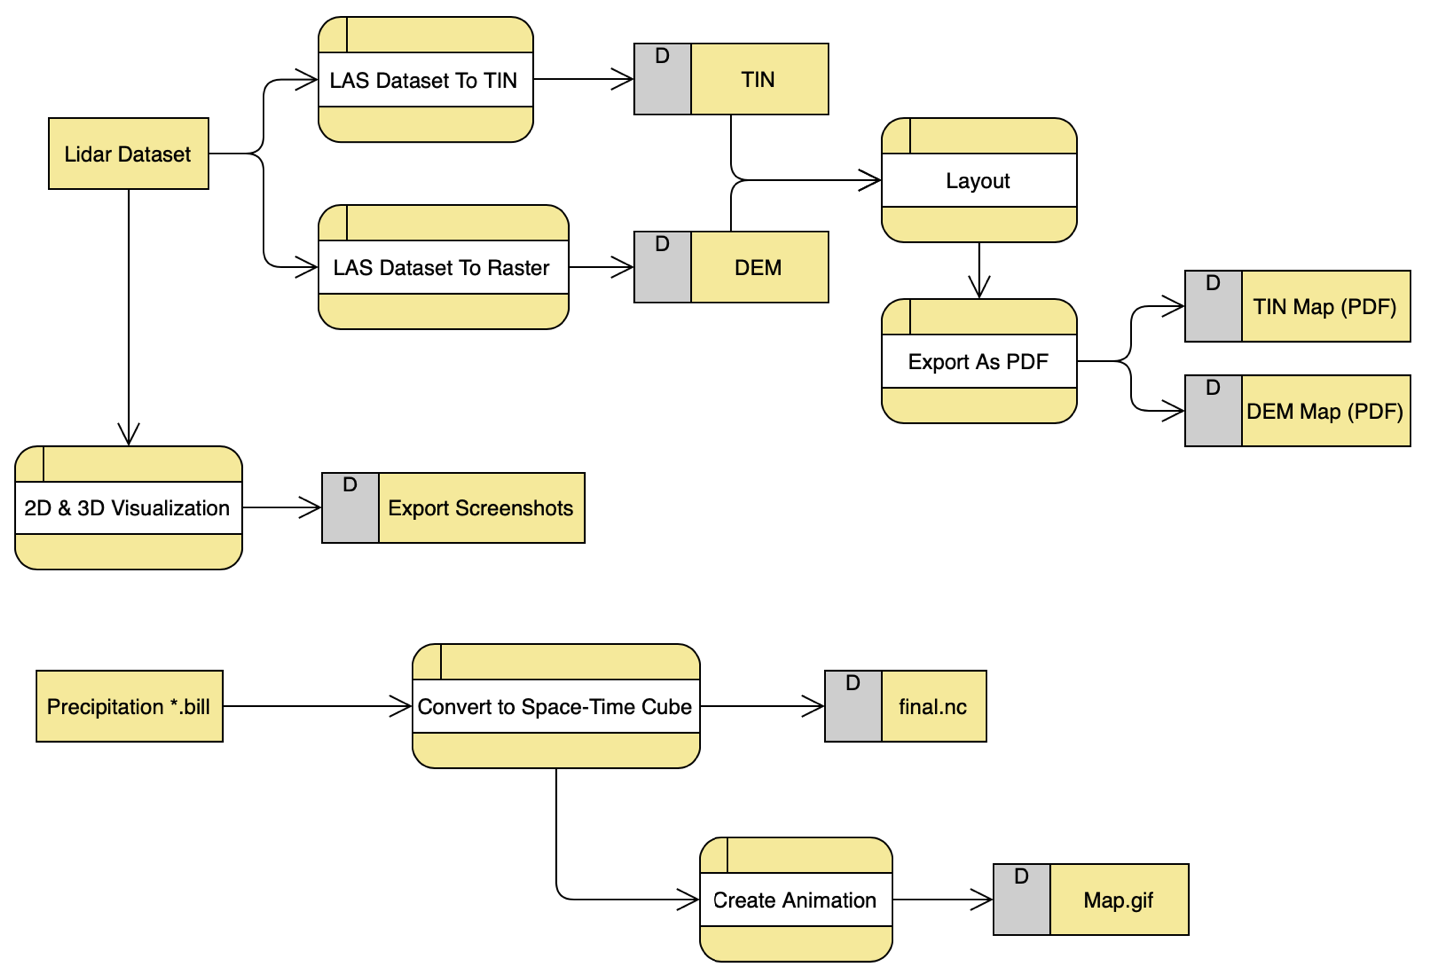

Figure 1. Data flow diagram for part 1.

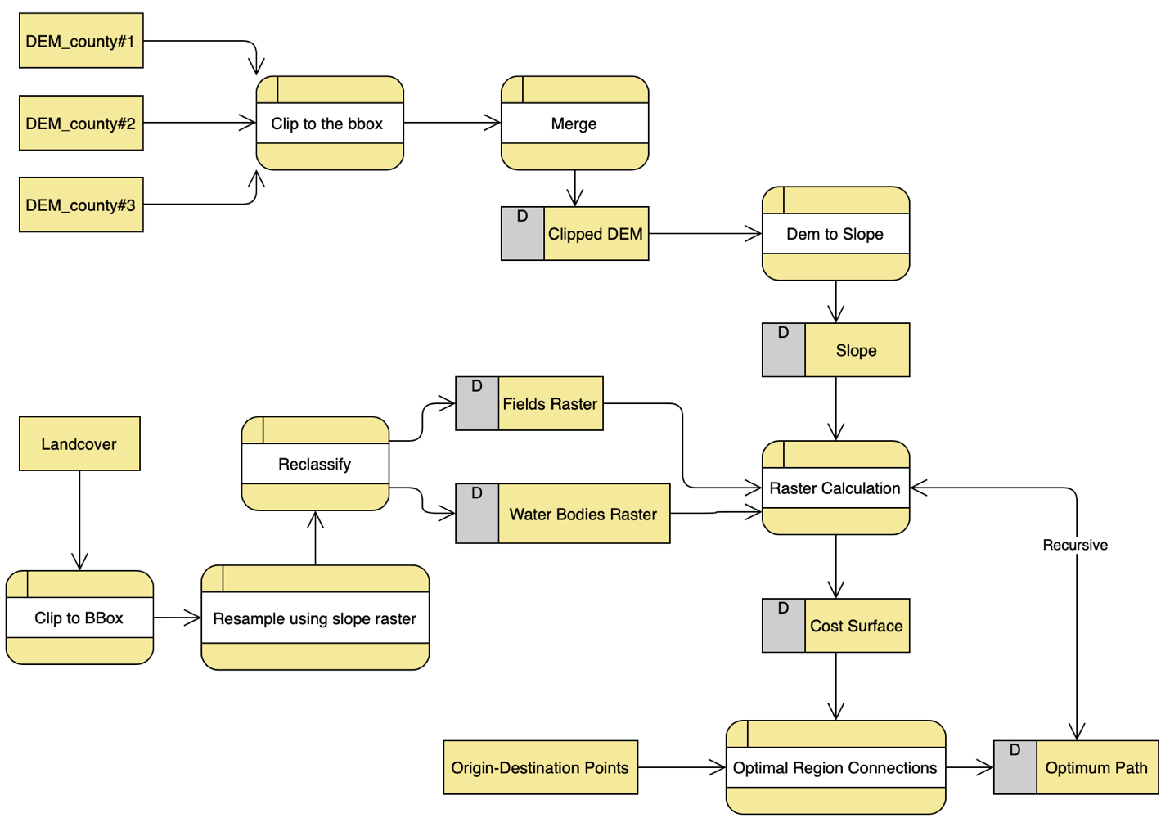

Figure 2. Data flow diagram for part 2.

**Results**

The results for part 1 are shown in figures 3 to 11. This part was mostly data conversion and visualization of the raster files and the 3D visualization of the multidimensional raster files.

In terms of part 2, the results are depicted in figures 12 to 16. These 6 figures are showing the outputs of all steps from data preparation to map algebra and cost surface creation. In this project in this part I created two different combination of criteria and cost surfaces. First, I considered the weights of -1 for Slope, -10 for farm, and -1 for water bodies. The resulting cost surface and corresponding optimal path are shown in figure 15. Next, I took another weighting approach considering the weights of -1 for Slope, -4 for farm, and -3 for water bodies. The resulting optimum path and cost surface are provided in figure 16.

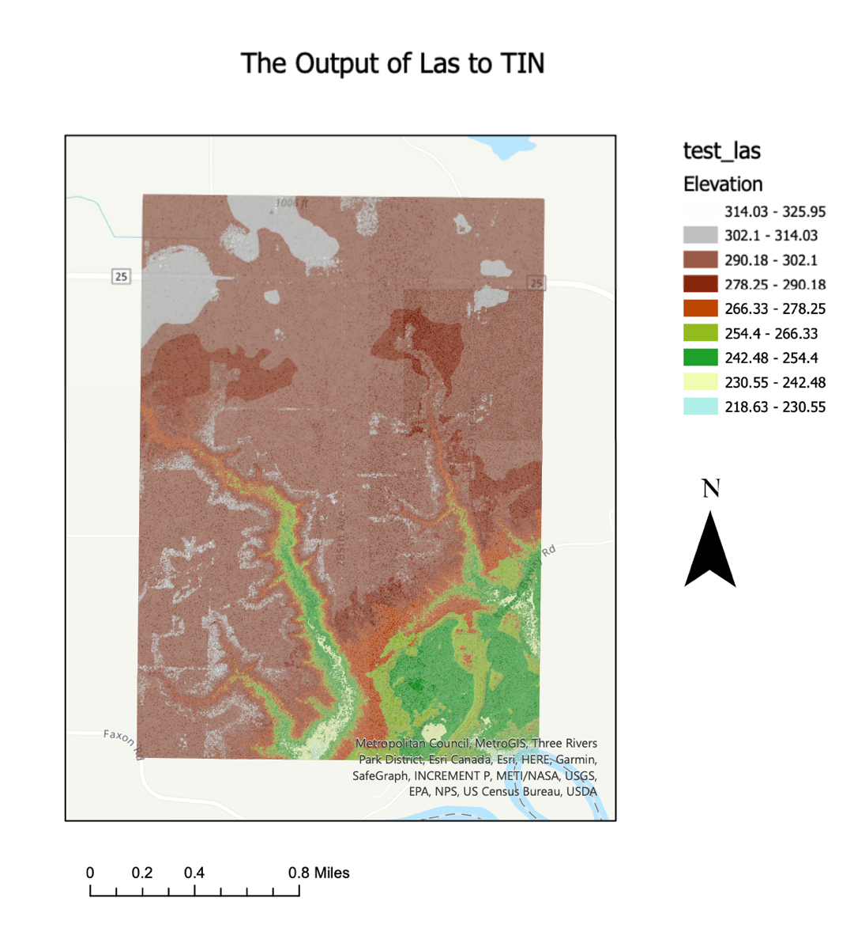

Figure 3. LAS to TIN output.

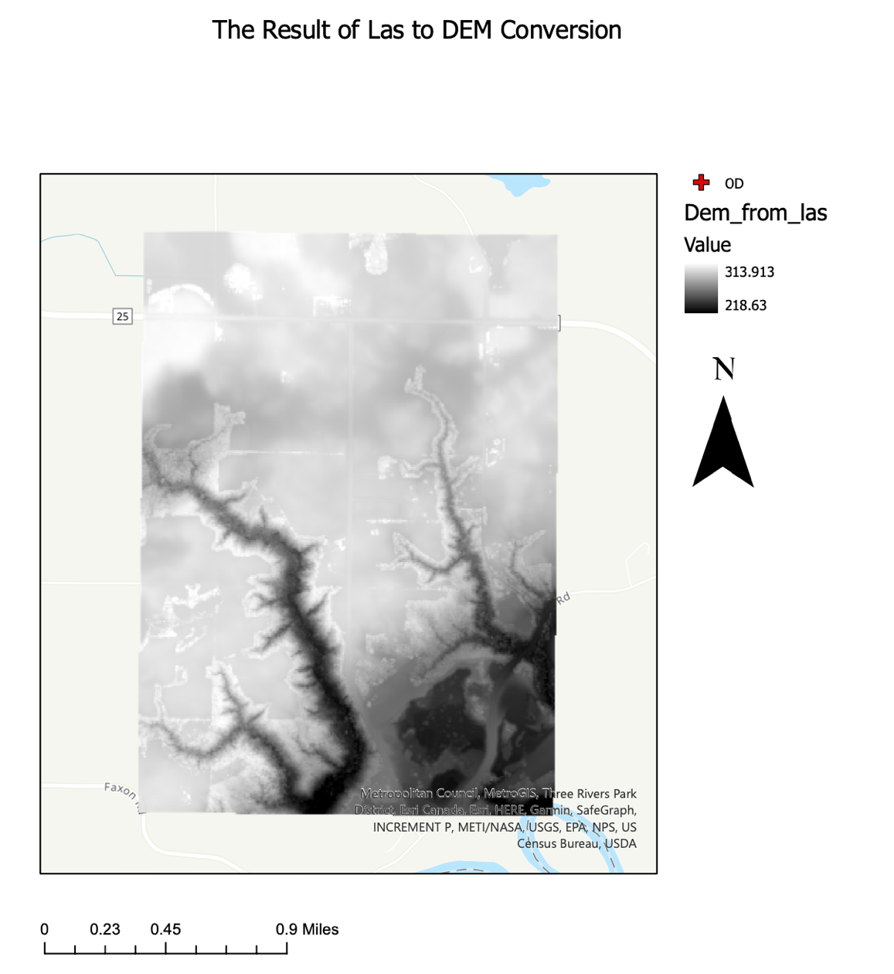

Figure 4. LAS to DEM output.

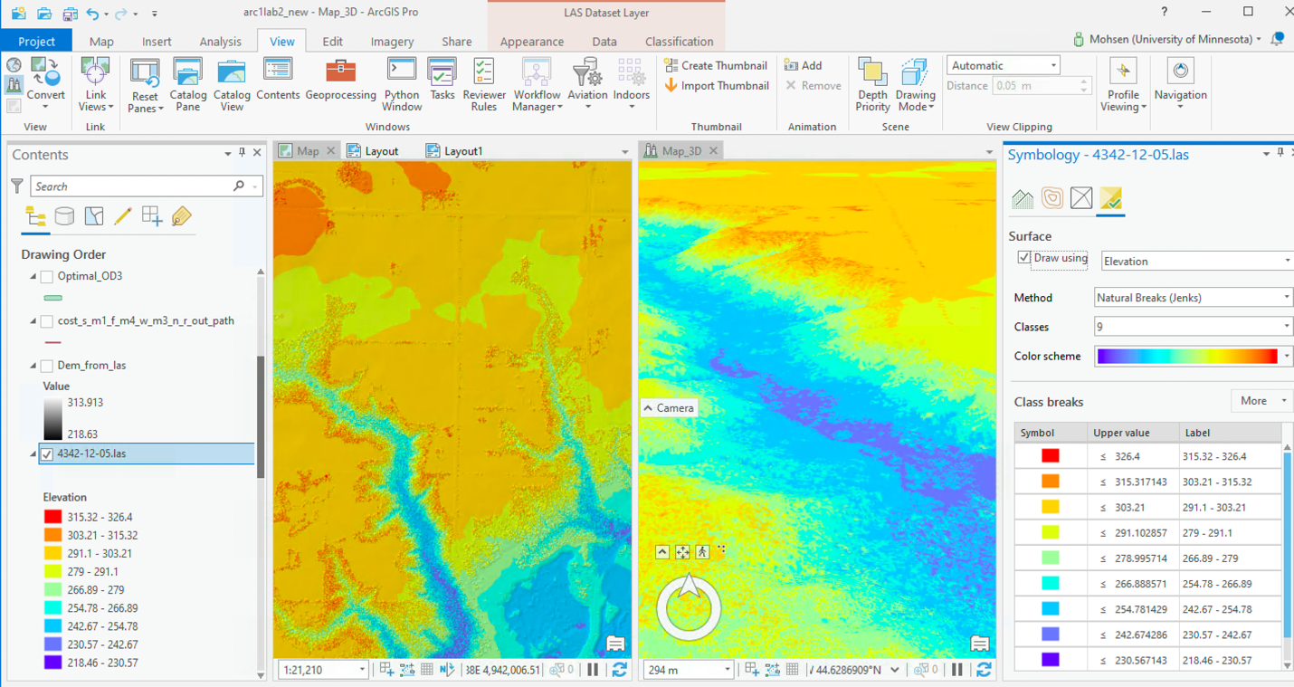

Figure 5. 2D and 3D data exploratory.

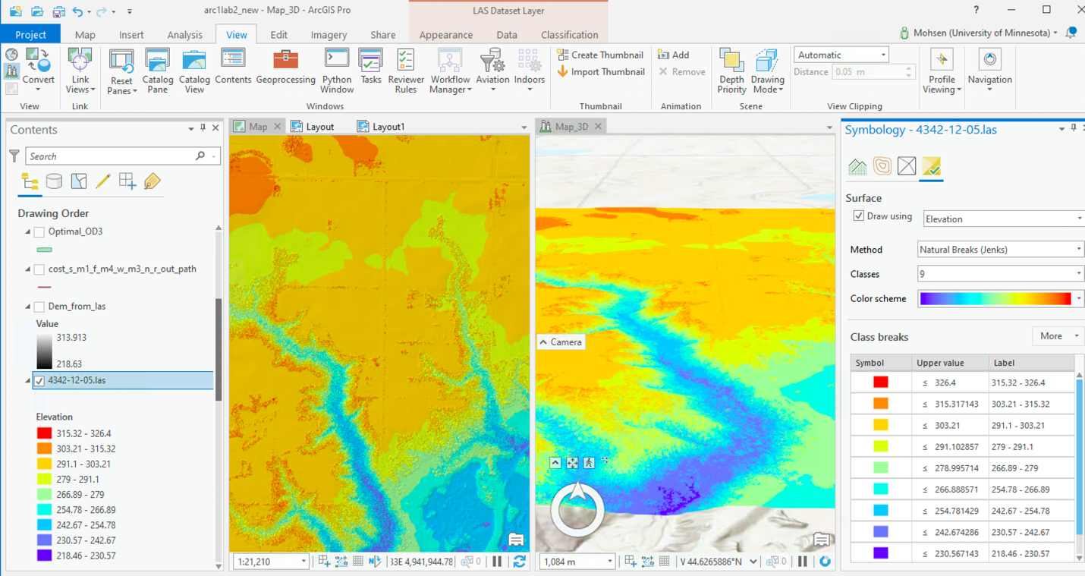

Figure 6. 2D and 3D data exploratory.

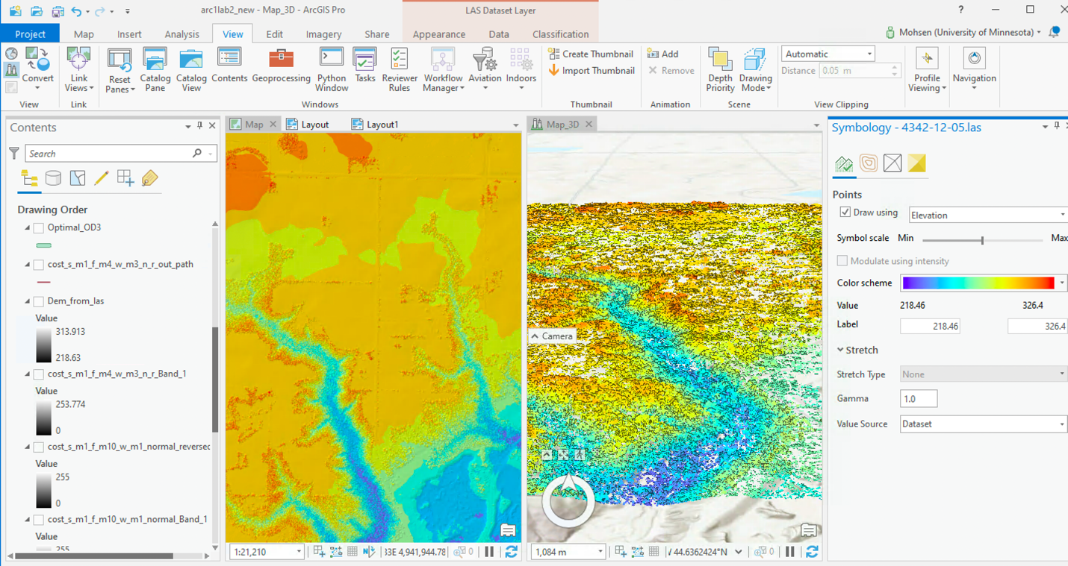

Figure 7. 2D and 3D data exploratory.

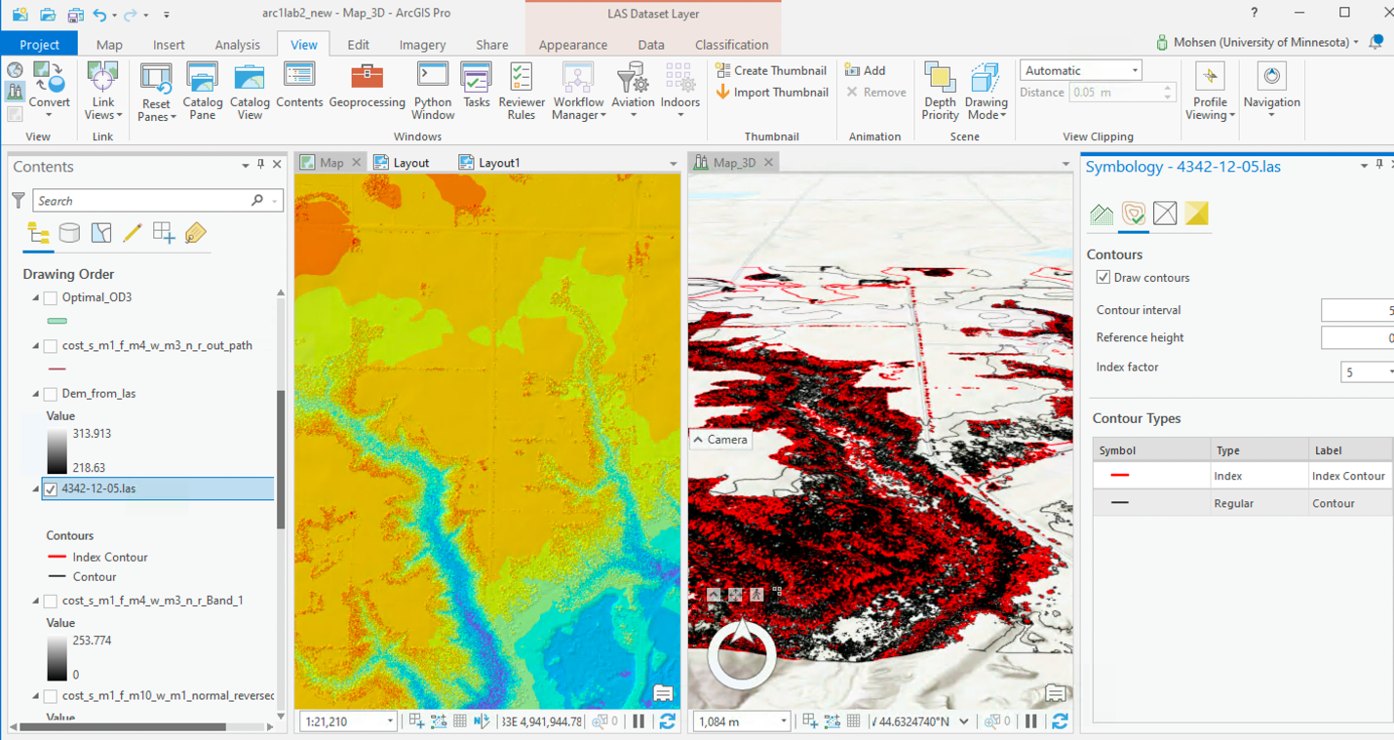

Figure 8. 2D and 3D data exploratory.

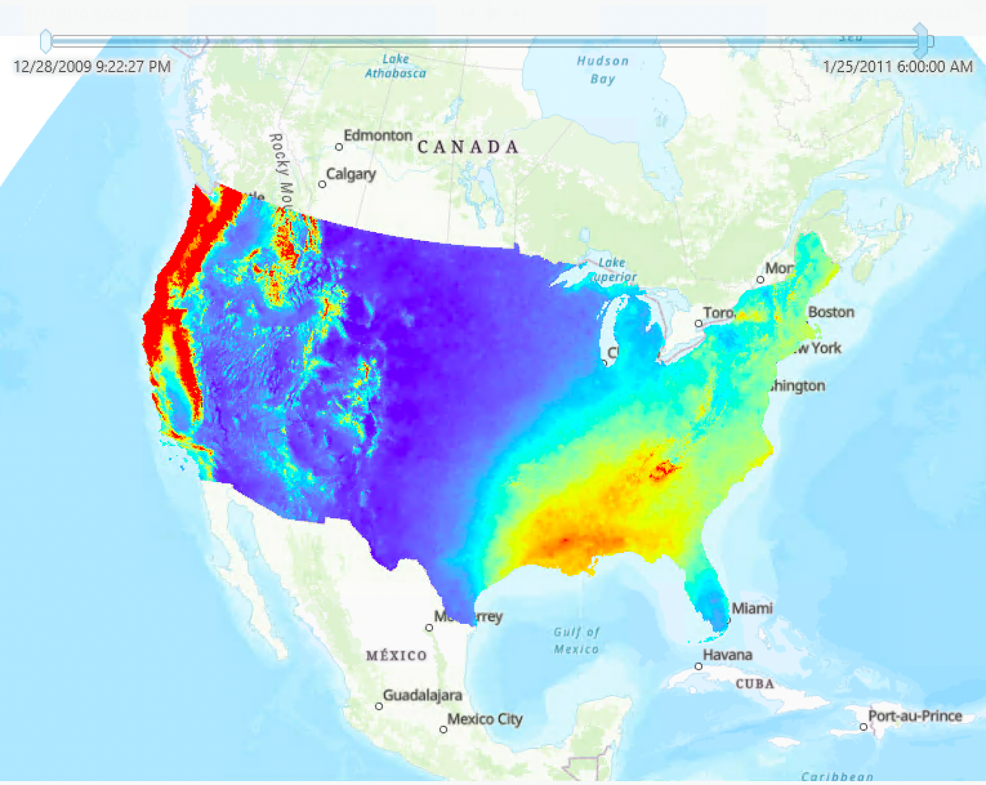

Figure 9. Resulting precipitation multidimensional raster layer with a slide-bar for time.

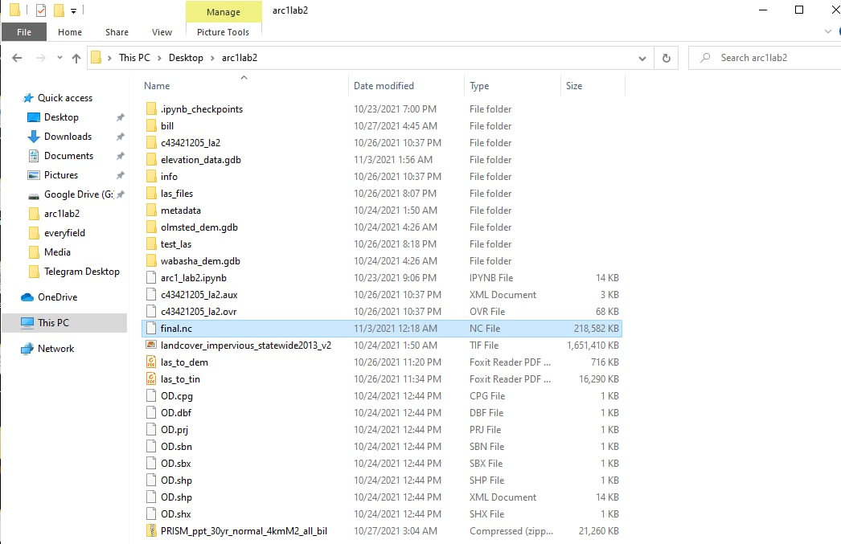

Figure 10. The resulting space-time cube saved into the workspace as final.nc.



Figure 11. The resulting animation of the space-time multidimensional raster layer.

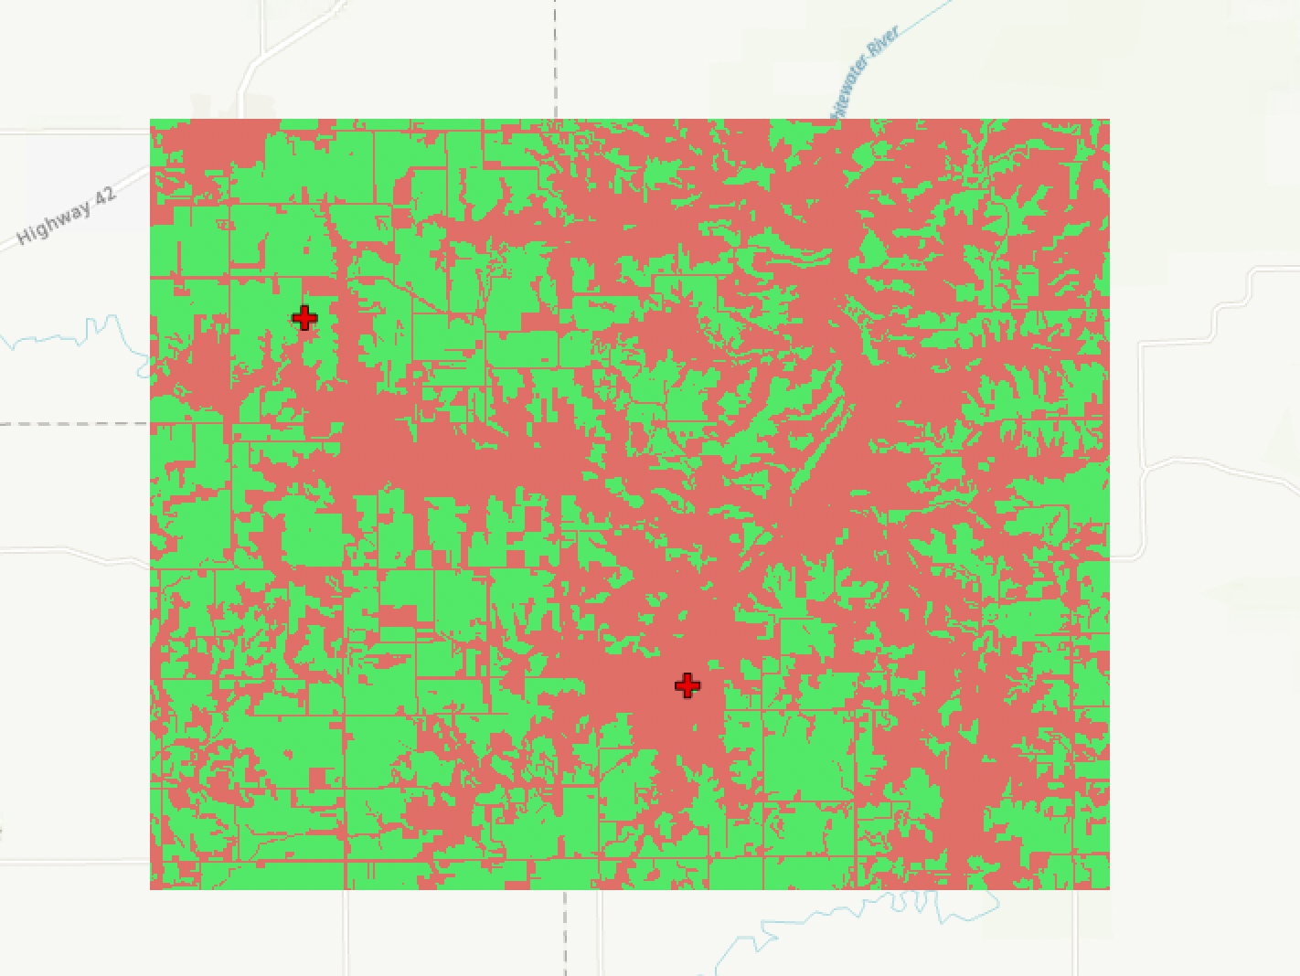

Figure 12. Farm (green) and non-farm (red) criterion raster (red cross marks indicate origin (top-left) and destination (bottom-right)).

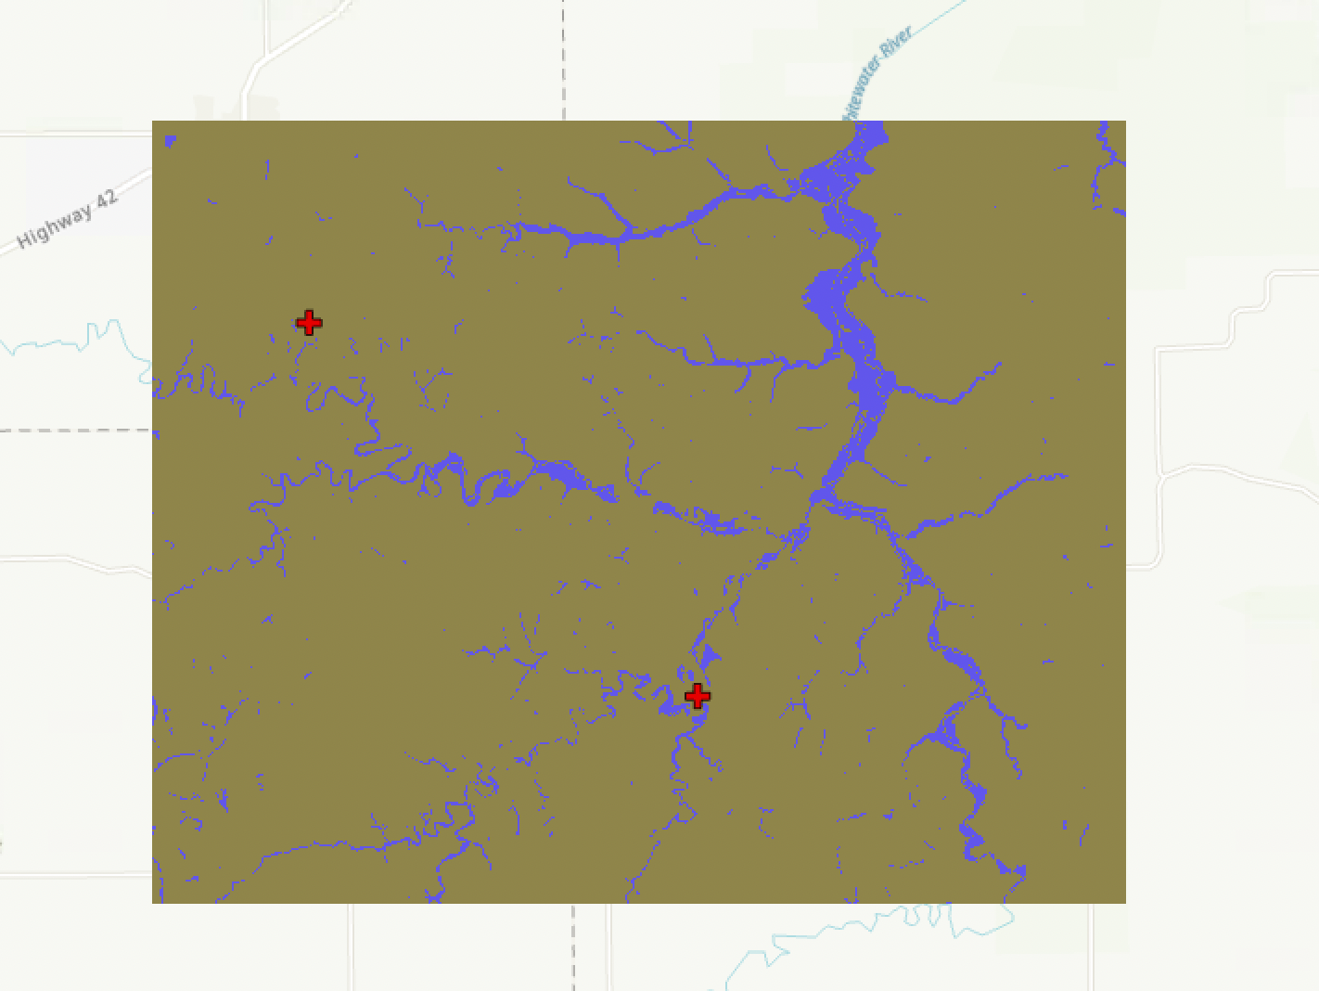

Figure 13. Water bodies criterion raster.

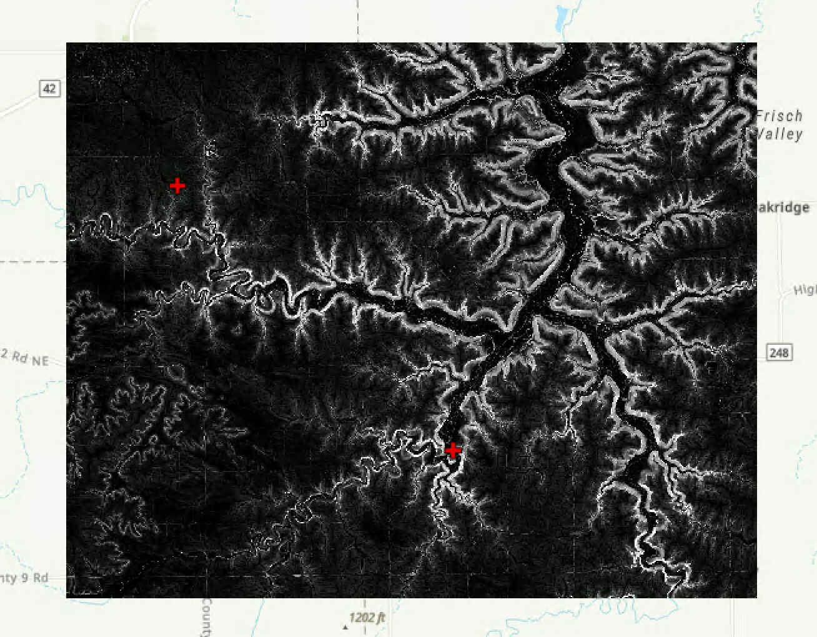

Figure 14. Slope criterion raster.

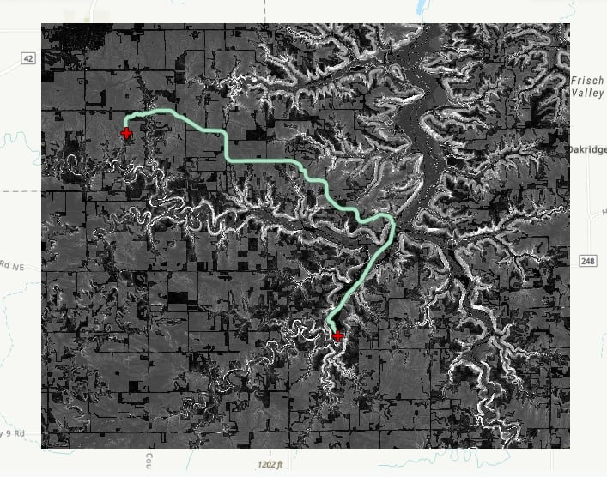

Figure 15. Scenario 1 resulting cost surface and optimum path: Slope (-1), farm (-10), water bodies (-1).

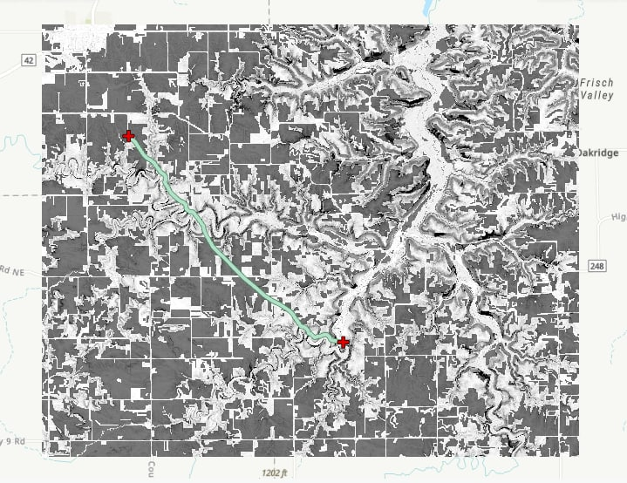

Figure 16. Scenario 2 resulting cost surface and optimum path: Slope (-1), farm (-4), water bodies (-3).

**Results Verification**

The part 1 of this project was not an analytical process. It was a procedure that mostly for visualization and manual data exploration. Therefore, it didn’t need a verification step. With regard to the second part, verification for each step was done by comparing the results with the hill shade of the base map in the ArcGIS Pro context. In other words, I used visual verification of the results in this step. Also, since the data datasets were downloaded from verified sources like MN GeoCommons and PRISM, they are already verified and are trustworthy. I also double checked to have consistent and unified geographical projection systems for all files.

**Discussion and Conclusion**

In the first part of the lab, I learned how to download and visualize a timeseries of raster files using ArcGIS Pro software and the arcpy module. It was a great experience to manipulate lidar files and generate different types of raster data. It was a challenging and solid procedure to get the hang of data conversion, TIN, and DEM data types, and working in the layout environment as well as exporting the layout as pdf. Also, working with *.bill file time series was a solid experience. I learned how to create a multidimensional raster and convert it to a space-time cube and exporting it as a *.nc file. Also, I had a chance to make use of the “view” tab in ArcGIS Pro and create an animation and export it as a *.gif file. Also, in terms of the second part, it was a practical experience working with raster files and run map algebra and raster calculation to generate a cost surface model.

The most significant challenge/limitation that I had was the load of the project. All the processes required a strong pc and high memory so that the execution be successful and fast. Unfortunately, I had to use my desktop computer at my office remotely which is not a strong system. Most of the time the computer were crashing and running out of memory so that all the process had to stop until I problem shoot the computer on campus. Also, I was hoping to be able to create many more maps for the cost surface part with many different combinations of the weights, but I couldn’t run more than two times.

**API for data collection**

All the APIs are provided as the links in table 2.

**References**

# 3D object scene layer symbology, <https://pro.arcgis.com/en/pro-app/latest/help/mapping/layer-properties/3d-object-scene-layer-symbology.htm>

1. Optimal Region Connections (Raster Analysis), <https://pro.arcgis.com/en/pro-app/latest/tool-reference/raster-analysis/optimal-region-connections.htm>
2. LAS Dataset To Raster, <https://desktop.arcgis.com/en/arcmap/10.3/tools/conversion-toolbox/las-dataset-to-raster.htm>
3. Date Functions, <https://developers.arcgis.com/arcade/function-reference/date_functions/>
4. Create Space Time Cube From Multidimensional Raster Layer (Space Time Pattern Mining), <https://pro.arcgis.com/en/pro-app/latest/tool-reference/space-time-pattern-mining/createcubefrommdrasterlayer.htm>
5. Explore your raster data with Space Time Pattern Mining, <https://www.esri.com/arcgis-blog/products/arcgis-pro/analytics/explore-your-raster-data-with-space-time-pattern-mining/>

**Self-score**

|  |  |  |  |
| --- | --- | --- | --- |
| **Category** | **Description** | **Points Possible** | **Score** |
| **Structural Elements** | All elements of a lab report are included **(2 points each)**:  Title, Notice: Dr. Bryan Runck, Author, Project Repository, Date, Abstract, Problem Statement, Input Data w/ tables, Methods w/ Data, Flow Diagrams, Results, Results Verification, Discussion and Conclusion, References in common format, Self-score | 28 | **26** |
| **Clarity of Content** | Each element above is executed at a professional level so that someone can understand the goal, data, methods, results, and their validity and implications in a 5 minute reading at a cursory-level, and in a 30 minute meeting at a deep level **(12 points)**. There is a clear connection from data to results to discussion and conclusion **(12 points)**. | 24 | **21** |
| **Reproducibility** | Results are completely reproducible by someone with basic GIS training. There is no ambiguity in data flow or rationale for data operations. Every step is documented and justified. | 28 | **28** |
| **Verification** | Results are correct in that they have been verified in comparison to some standard. The standard is clearly stated **(10 points)**, the method of comparison is clearly stated **(5 points)**, and the result of verification is clearly stated **(5 points)**. | 20 | **20** |
|  |  | 100 | **95** |